



# PANIMALAR INSTITUTE OF TECHNOLOGY

# CHENNAI – 600 123

PROJECT

# “PERSONAL EXPENSE TRACKER APPLICATION”

**DONE BY**

**TEAM ID: PNT2022TMID25814**

**D. JACOB INIYAN CORNELIUS (211519104056)**

**K. ATHITHYA (211519104024)**

**R. DILIP KUMAR**

**(211519104034)**

**R. FELIX ROGER (211519104042)**

**TABLE OF CONTENT**

## **1. INTRODUCTION**

1. Project Overview
2. Purpose

## **2. LITERATURE SURVEY**

1. Existing problem
2. Problem Statement Definition

## **3.IDEATION & PROPOSED SOLUTION**

1. Empathy Map Canvas
2. Ideation & Brainstorming
3. Proposed Solution
4. Problem Solution fit

## **4. REQUIREMENT ANALYSIS**

1. Functional requirement
2. Non-Functional requirements

## **5. PROJECT DESIGN**

1. Data Flow Diagrams
2. Solution & Technical Architecture
3. User Stories

## **6. PROJECT PLANNING & SCHEDULING**

1. Sprint Planning & Estimation
2. Sprint Delivery Schedule

## **7. CODING & SOLUTIONING (Explain the features added in the project along with code)**

1. Feature 1
2. Feature 2

## **8. RESULTS**

1.Performance Metrics

## **9.ADVANTAGES & DISADVANTAGES**

**10. CONCLUSION**

**11.FUTURE SCOPE**

**12.APPENDIX**

Source Code

GitHub & Project Demo Link

**1.INTODUCTION**

**PROJECT OVERVIEW:**

Expense tracker is an android based application. This application allows the user to maintain a computerized diary. Expense tracker application which will keep a track of Expenses of a user on a day-to-day basis. This application keeps a record of your expenses and also will give you a category wise distribution of your expenses. With the help of this application user can track their daily/weekly/monthly expenses.

This application will also have a feature which will help you stay on budget because you know your expenses. Expense tracker application will generate report at the end of month to show Expense via a graphical representation. We also have added a special feature which will distributes your expenses in different categories suitable for the user. An expense history will also be provided in application.

**2. LITERATURE SURVEY**

**A. Intelligent Online Budget Tracker**

The development of this application has been conducted in a stepwise manner using the well-defined methodology. RUP customized according to the requirements of the system. Most of the goals set at the start of the development phase have been met Security problems like web security or network security have also been treated in the design and development of the system, thus increasing the reliability of the system. Quality management issues have also been handled satisfactorily.

**B. Online Income and Expense Tracker**

This project is work more efficient than the other income and expense tracker. The project successfully avoids the manual calculation for calculating the income and expense per month. The modules are developed efficiently and also in an attractive manner.

**C. Family Expense Manager Application**

As the result, the user can make use of this application in his her daily life. After being used it can be a part of daily life to update and view daily expenses and family expenses. This helps to keep track of expenses & manage it for the user as they are busy in their daily routine, they are not able to keep track of their incomes & expenses.

**D. Personalized Expense Managing Assistant Using Android**

Some of the features are like enabling users to register to the application using an existing email or social network account, it will synchronize the user's profile information to the application. Apart from this, the application can be used to gather samples of data related to user's expenses with consents and use those sample data as parameters to assess patterns of spending. Using some data mining techniques expenses can be classified and can be used in market analysis and planning.

**3. IDEATION & PROPOSED SOLUTION**

**3.1 EMPATHY MAP CANVAS**

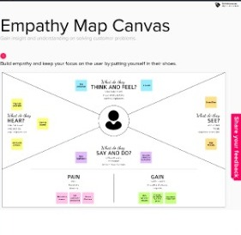

**3.2 IDEATION & BRAINSTORMING**

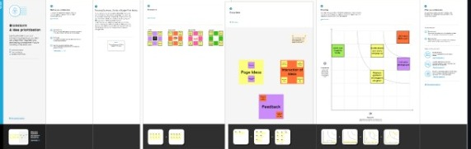

**3.3 PROPOSEED SOLUTION**

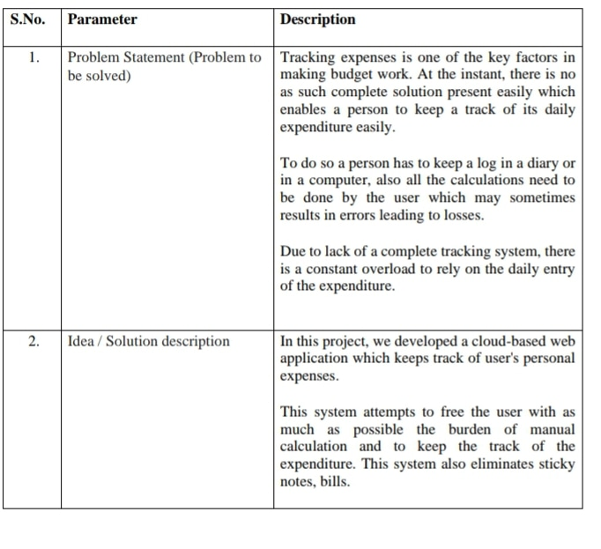

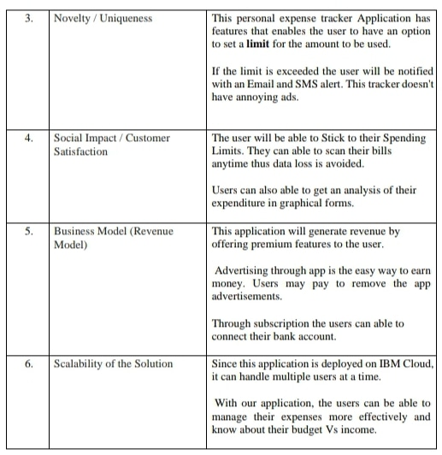

**3.4 PROBLEM SOLUTION FIT**

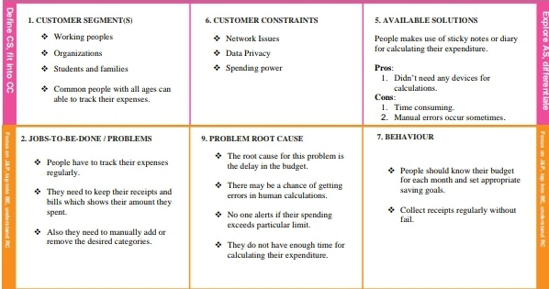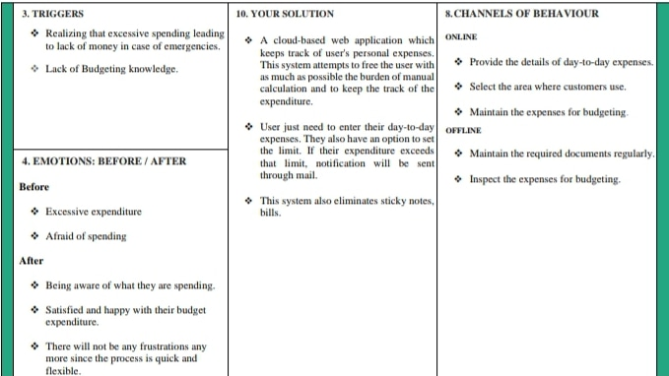

**4. REQUIREMENT ANALYSIS**

**4.1 FUNCTIONAL ANALYSIS**

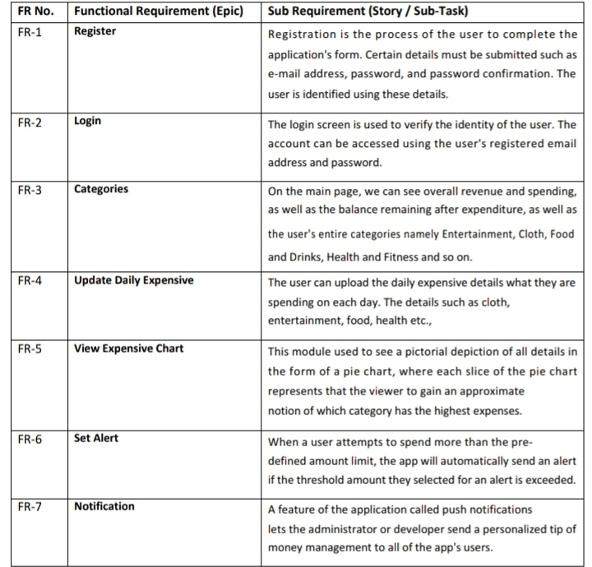

**4.2 NON-FUNCTIONAL ANALYSIS**

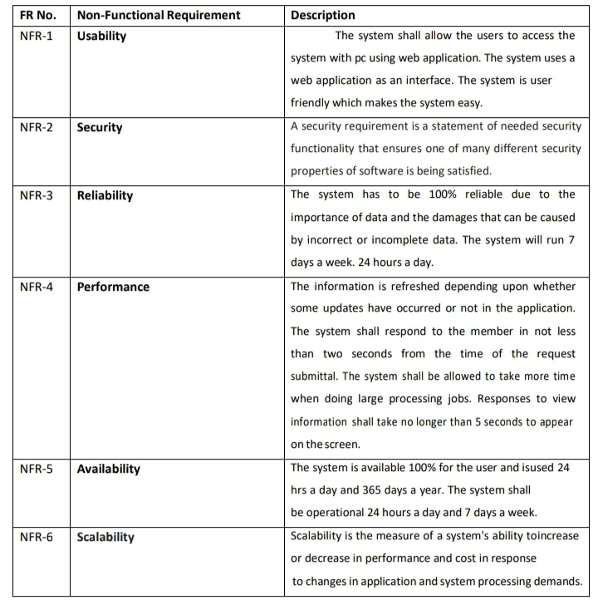

**5. PROJECT DESIGN**

**5.1 DATA FLOW DIAGRAM**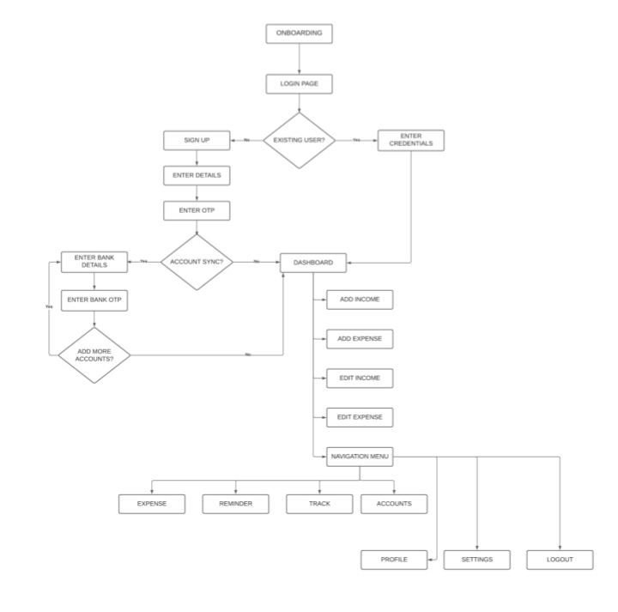

**5.2 SOLUTION AND TECHNICAL ARCHITECTURE**

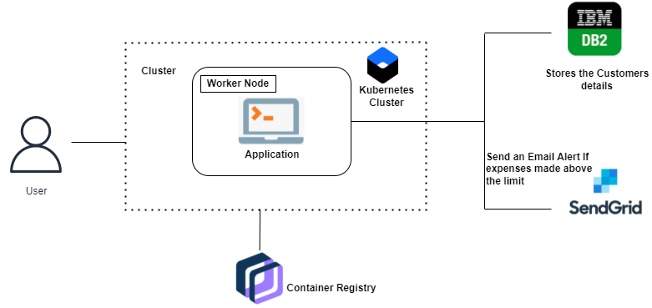

**6. PROJECT PLANNING & SCHEDULING**

|  |  |  |  |  |  |  |
| --- | --- | --- | --- | --- | --- | --- |
| **User Type** | **Functional Requirement (Epic)** | **User Story Number** | **User Story / Task** | **Story Points** | **Priority** | **Team members** |
| Customer (Mobile user) | Registration | USN-1 | As a user, I can register for the application by entering my email, password, and confirming my  password. | 8 | High | Team Lead |
|  |  | USN-2 | As a user, I will receive confirmation email once I have registered for the application | 6 | High | Team Member-1 |
|  |  | USN-3 | As a user, I can register for the application through Facebook | 7 | Low | Team Member-2 |
|  |  | USN-4 | As a user, I can register for the application through Gmail | 8 | Medium | Team Member-3 |
|  | Login | USN-5 | As a user, I can log into the application by entering email & password | 9 | High | Team Lead |
|  | Dashboard | USN-6 | As a user, I can add my day-today expenses regularly. | 8 | High | Team Member-1 |
| Customer (Web user) | Dashboard | USN-7 | As a user, I can see login page and registration page for which the user logins and input expenses. | 7 | Medium | Team Member-3 |
| Customer  Care Executive | Dashboard | USN-8 | As a customer care executive, I can solve the queries of users. | 8 | High | Team Member-2 |
| Administrator | Registration | USN-9 | As an Administrator, I can view the basic details of user. | 7 | Medium | Team Lead |
|  | Dashboard | USN-10 | As an administrator, I can able to view the overall progress of a user. | 6 | Low | Team Member-3 |

**Project Tracker, Velocity & Burndown Chart:**

|  |  |  |  |  |  |  |
| --- | --- | --- | --- | --- | --- | --- |
| **Sprint** | **Total Story Point** | **Duration** | **Sprint Start Date** | **Sprint End Date (Planned)** | **Story Points Completed (as on Planned End**  **Date)** | **Sprint Release Date (Actual)** |
| Sprint-1 | 20 | 6 Days | 24 Oct 2022 | 29 Oct 2022 | 20 | 29 Oct 2022 |
| Sprint-2 | 20 | 6 Days | 31 Oct 2022 | 05 Nov 2022 | 20 | 05 Nov 2022 |
| Sprint-3 | 20 | 6 Days | 07 Nov 2022 | 12 Nov 2022 | 20 | 12 Nov 2022 |

|  |  |  |  |  |  |  |
| --- | --- | --- | --- | --- | --- | --- |
| Sprint-4 | 20 | 6 Days | 14 Nov 2022 | 19 Nov 2022 | 20 | 19 Nov 2022 |

**Velocity:**

Imagine we have a 10-day sprint duration, and the velocity of the team is 20 (points per sprint). Let’s calculate the team’s average velocity (AV) per iteration unit (story points per day)



|  |  |
| --- | --- |
| Sprint | Average Velocity |
| Sprint-1 | 6.5 |
| Sprint-2 | 8 |
| Sprint-3 | 8.2 |
| Sprint-4 | 8 |

Total Average Velocity=7.5

**Burndown Chart:**

A burn down chart is a graphical representation of work left to do versus time. It is often used in agile [software development](https://www.visual-paradigm.com/scrum/what-is-agile-software-development/) methodologies such as [Scrum.](https://www.visual-paradigm.com/scrum/scrum-in-3-minutes/) However, burn down charts can be applied to any project containing measurable progress over time

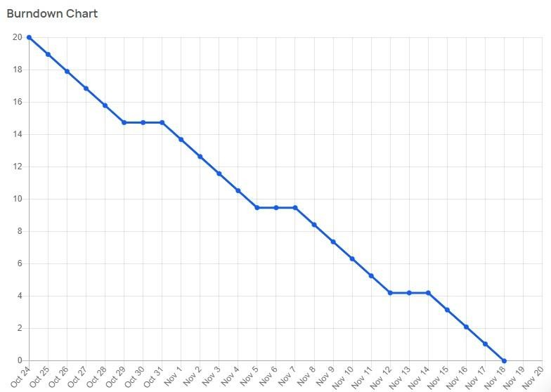

**8. RESULTS**

SOME SCREENSHOTS OF THE PROJECT ARE GIVEN BELOW

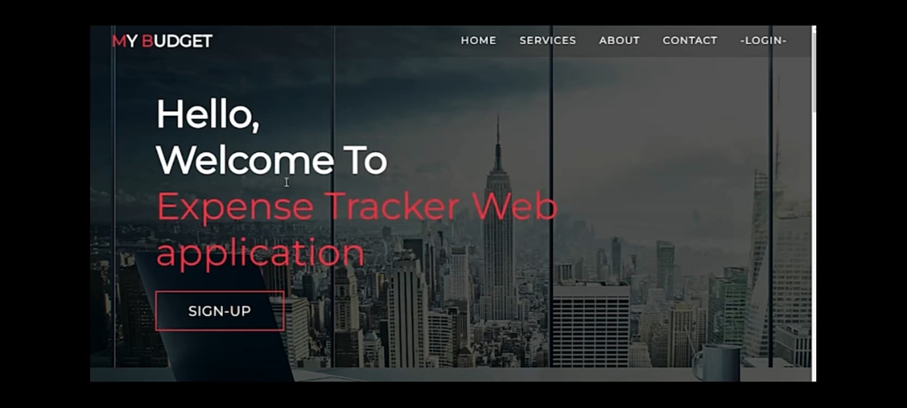

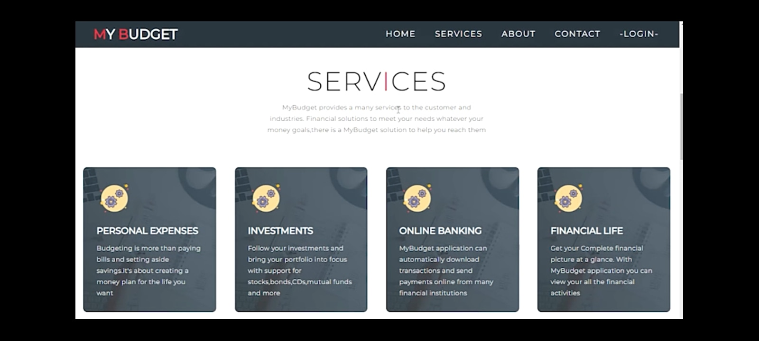

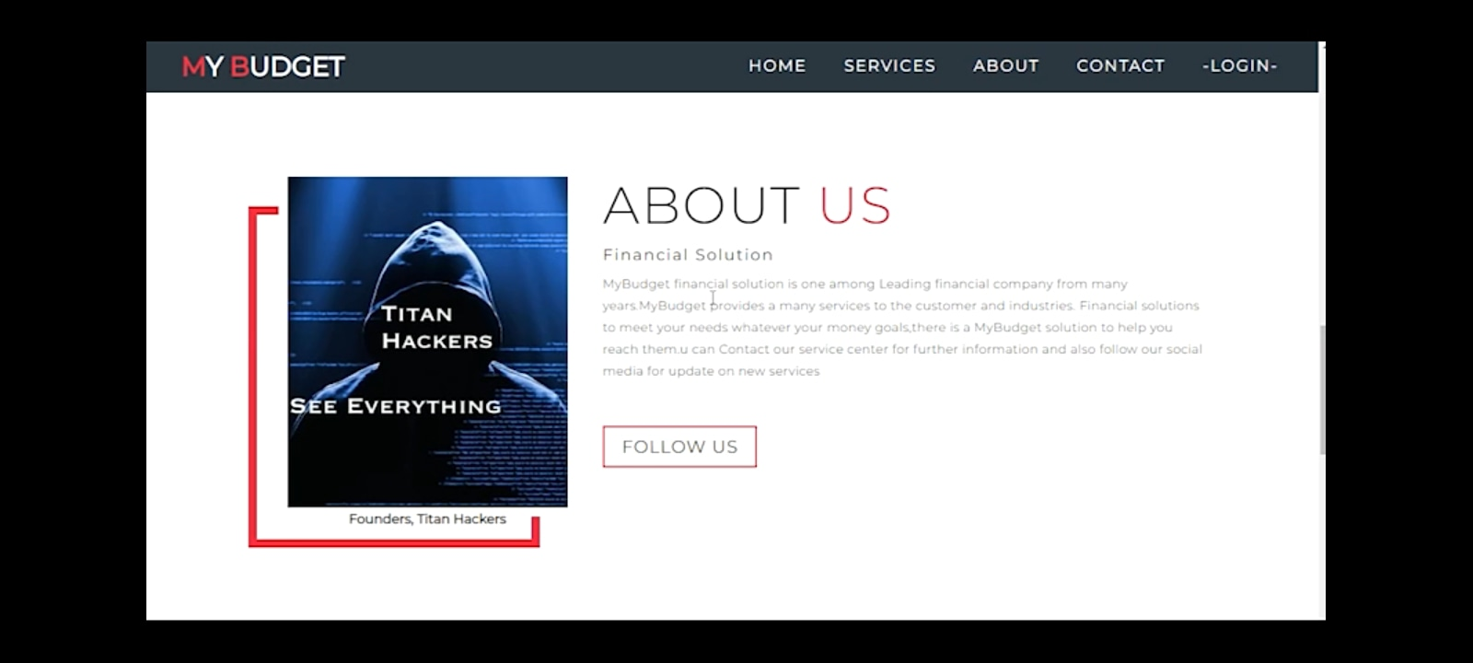

**LOGIN PAGE:**

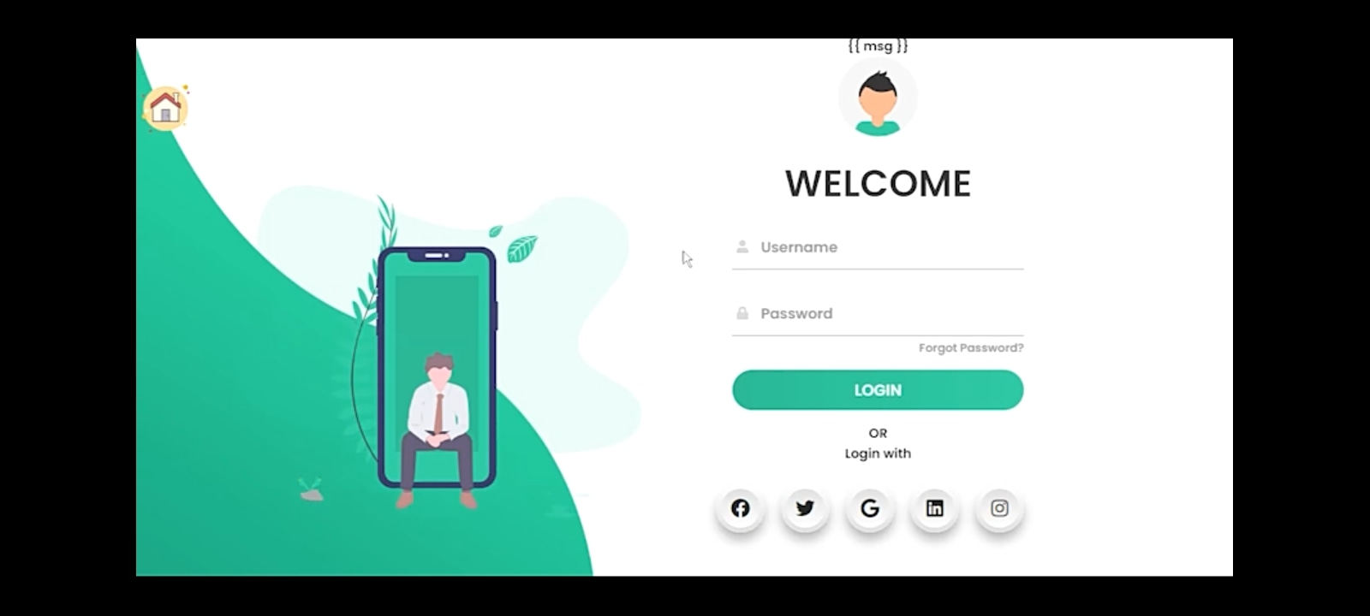

**SIGNUP PAGE:**

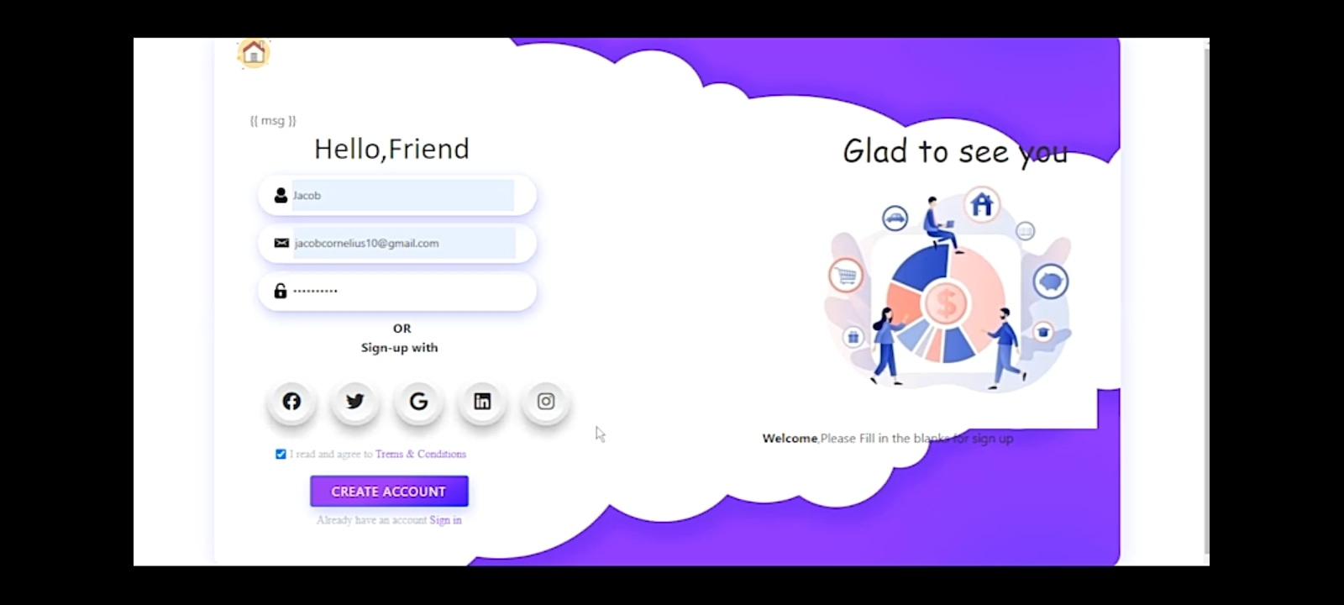

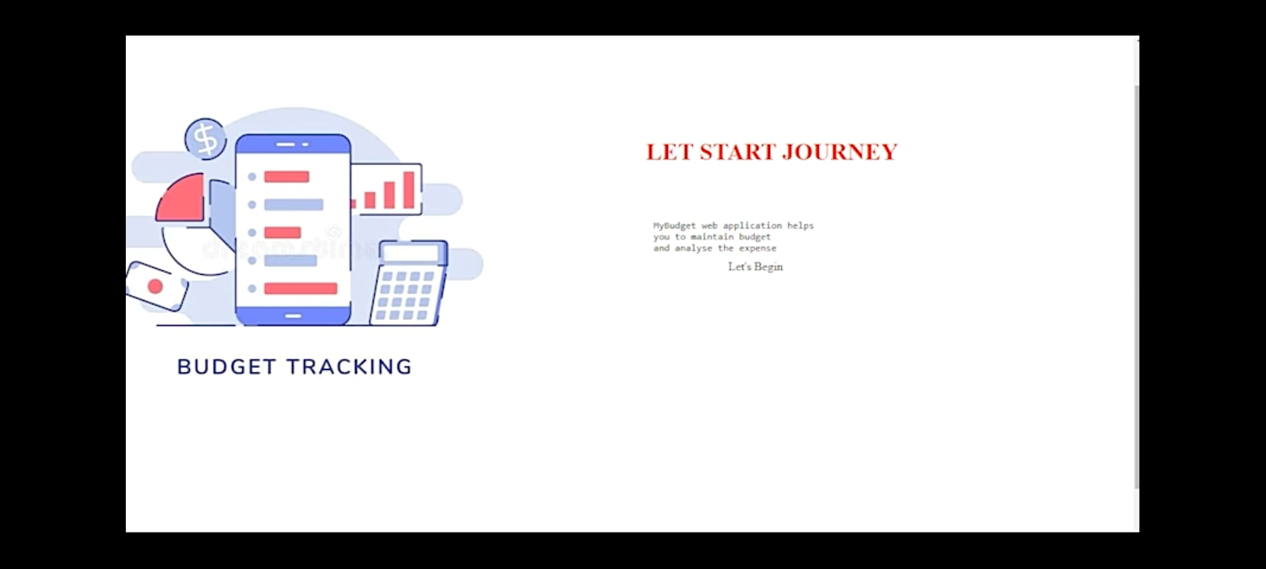

**9. ADVANTAGES & DIS-ADVANTAGES**

**PROS:**

One of the major pros of tracking spending is always being aware of the state of one's personal finances. Tracking what you spend can help you stick to your budget, not just in a general way, but in each category such as housing, food, transportation and gifts. While a con is that manually tracking all cash that is spent can be irritating as well as time consuming, a pro is that doing this automatically can be quick and simple.

Another pro is that many automatic spending tracking software programs are available for free. Having the program on a hand-held device can be a main pro since it can be checked before spending occurs in order to be sure of the available budget. Another pro is that for those who just wish to keep tracking spending by hand with a paper and pen or by entering data onto a computer spreadsheet, these options are also available.

Some people like to keep a file folder or box to store receipts and record the cash spent each day. A pro of this simple daily tracking system is that it can make one more aware of where the money is going way before the end of a pay period or month.

**CONS:**

A con with any system used to track spending is that one may start doing it then taper off until it's forgotten about all together. Yet, this is a risk for any new goal such as trying to lose weight or quit smoking.

If a person first makes a budget plan, then places money in savings before spending any each new pay period or month, the tracking goal can help.

In this way, tracking spending and making sure all receipts are accounted for only needs to be done once or twice a month. Even with constant tracking of one's spending habits, there is no guarantee that financial goals will be met.

Although this can be considered to be a con of tracking spending, it could be changed into a pro if one makes up his or her mind to keep trying to properly manage all finances.

Another con that may occur when spending is being tracked is an error, but this may also be able to be changed into a pro if the person does regular tracking. Frequent tracking of cash spending can allow one to catch and correct errors so that the budget plan is still able to be adhered to despite the mistake.

**10. CONCLUSION**

Expenses Tracker System is a system that being developed to assist users in budget planning.

It provides end users to records their income and expenses within thebudget that have been planned beforehand.

Furthermore, users are able to keep track on their spending so they are not wasting their money without doubt.

Last but certainly not the least, they are able to access the system anytime and anywhere that is accessible.

**11. FUTURE SCOPE**

The Future Enhancements of the application can be allowed to support in all the upcoming android versions. History can be set to view all the details in the app even if the particular data is deleted from the database. Statistics could be prepared based on the Income, Expense details of the user. Sharing files via Bluetooth, WhatsApp can be allowed. Printing the details of the particular income or expense details can be made. Some of the extra components are like enabling users to register to the application using existing email or social network account, it will synchronize the users profile data to the application.

**12. APPENDIX**

SOURCE CODE 1:

<!DOCTYPE html>

<html lang="en">

<head>

<meta charset="UTF-8">

<meta name="viewport" content="width=device-width, initial-scale=1.0">

<link rel="stylesheet" href="..\static\css\home.css">

<title>My Website</title>

</head>

<body>

<!-- Header -->

<section id="header">

<div class="header container">

<div class="nav-bar">

<div class="brand">

<a href="#hero">

<h1><span>M</span>y <span>B</span>udget</h1>

</a>

</div>

<div class="nav-list">

<div class="hamburger">

<div class="bar"></div>

</div>

<ul>

<li><a href="#hero" data-after="Home">Home</a></li>

<li><a href="#services" data-after="Service">Services</a></li>

<li><a href="#about" data-after="About">About</a></li>

<li><a href="#contact" data-after="Contact">Contact</a></li>

<LI><a href="/signin" data-after="Login">-Login-</a></LI>

</ul>

</div>

</div>

</div>

</section>

<!-- End Header -->

<!-- Hero Section -->

<section id="hero">

<div class="hero container">

<div>

<h1>Hello, <span></span></h1>

<h1>Welcome To <span></span></h1>

<h1>Expense Tracker Web application <span></span></h1>

<a href="/signup" type="button" class="cta">Sign-up</a>

</div>

</div>

</section>

<!-- End Hero Section -->

<!-- Service Section -->

<section id="services">

<div class="services container">

<div class="service-top">

<h1 class="section-title">Serv<span>i</span>ces</h1>

<p>MyBudget provides a many services to the customer and industries. Financial solutions to meet your needs whatever your money goals,there is a MyBudget solution to help you reach them </p>

</div>

<div class="service-bottom">

<div class="service-item">

<div class="icon"><img src="https://img.icons8.com/bubbles/100/000000/services.png" /></div>

<h2>Personal Expenses</h2>

<p>Budgeting is more than paying bills and setting aside savings.it's about creating a money plan for the life you want</p>

</div>

<div class="service-item">

<div class="icon"><img src="https://img.icons8.com/bubbles/100/000000/services.png" /></div>

<h2>Investments</h2>

<p>Follow your investments and bring your portfolio into focus with support for stocks,bonds,CDs,mutual funds and more</p>

</div>

<div class="service-item">

<div class="icon"><img src="https://img.icons8.com/bubbles/100/000000/services.png" /></div>

<h2>Online Banking</h2>

<p>MyBudget application can automatically download transactions and send payments online from many financial institutions</p>

</div>

<div class="service-item">

<div class="icon"><img src="https://img.icons8.com/bubbles/100/000000/services.png" /></div>

<h2>Financial Life</h2>

<p>Get your Complete financial picture at a glance. With MyBudget application you can view your all the financial activities

</p>

</div>

</div>

</div>

</section>

<!-- End Service Section -->

<!-- About Section -->

<section id="about">

<div class="about container">

<div class="col-left">

<div class="about-img">

<img src="..\static\images\titan hackers.jpg" alt="img">

<div><h2>Founders, Titan Hackers </h2></div>

</div>

<div>

<div class="col-right">

<h1 class="section-title">About <span>Us</span></h1>

<h2>Financial Solution</h2>

<p>MyBudget financial solution is one among Leading financial company from many years.MyBudget provides a many services to the customer and industries. Financial solutions to meet your needs whatever your money goals,there is a MyBudget solution to help you reach them.u can Contact our service center for further information and also follow our social media for update on new services </p>

<a href="#footer" class="cta">Follow Us</a>

</div>

</div>

</section>

<!-- End About Section -->

<!-- Contact Section -->

<section id="contact">

<div class="contact container">

<div>

<h1 class="section-title">Contact <span>info</span></h1>

</div>

<div class="contact-items">

<div class="contact-item">

<div class="icon"><img src="https://img.icons8.com/bubbles/100/000000/phone.png" /></div>

<div class="contact-info">

<h1>Phone</h1>

<h2>+1 234 123 1234</h2>

<h2>+1 234 123 1234</h2>

</div>

</div>

<div class="contact-item">

<div class="icon"><img src="https://img.icons8.com/bubbles/100/000000/new-post.png" /></div>

<div class="contact-info">

<h1>Email</h1>

<h2>info@gmail.com</h2>

<h2>abcd@gmail.com</h2>

</div>

</div>

<div class="contact-item">

<div class="icon"><img src="https://img.icons8.com/bubbles/100/000000/map-marker.png" /></div>

<div class="contact-info">

<h1>Address</h1>

<h2>4th main-road,Bengaluru,Karnataka,India</h2>

</div>

</div>

</div>

</div>

</section>

<!-- End Contact Section -->

<!-- Footer -->

<section id="footer">

<div class="footer container">

<div class="brand">

<h1><span>M</span>y <span>B</span>udget</h1>

</div>

<h2>Your Complete Financial Solution</h2>

<div class="social-icon">

<div class="social-item">

<a href="#"><img src="https://img.icons8.com/bubbles/100/000000/facebook-new.png" /></a>

</div>

<div class="social-item">

<a href="#"><img src="https://img.icons8.com/bubbles/100/000000/instagram-new.png" /></a>

</div>

<div class="social-item">

<a href="#"><img src="https://img.icons8.com/bubbles/100/000000/behance.png" /></a>

</div>

</div>

<p>Copyright © 2022 SECE "Titan Hackers" . All rights reserved</p>

</div>

</section>

<!-- End Footer -->

<script src="..\static\js\home.js"></script>

</body>

</html>

SOURCE CODE 2:

<!DOCTYPE html>

<html>

<head>

<title>Animated Login Form</title>

<link rel="stylesheet" type="text/css" href="..\static\css\login.css">

<link href="https://fonts.googleapis.com/css?family=Poppins:600&display=swap" rel="stylesheet">

<script src="https://kit.fontawesome.com/a81368914c.js"></script>

<meta name="viewport" content="width=device-width, initial-scale=1">

</head>

<body >

<img class="wave" src="..\static\images\wave.png">

<div class="container">

<div class="img">

<div id="png"><a href="/" title="HOME"><img style="width:75px; height:75px ; " src="..\static\images\home-page.png"></a></div>

<img src="..\static\images\bg.svg">

</div>

<div class="login-content">

<form action='/login' method="POST">

<div class="msg">{{ msg }}</div>

<img src="..\static\images\avatar.svg">

<h2 class="title">Welcome</h2>

<div class="input-div one">

<div class="i">

<i class="fas fa-user"></i>

</div>

<div class="div">

<h5>Username</h5>

<input type="text" name="username" class="input" required>

</div>

</div>

<div class="input-div pass">

<div class="i">

<i class="fas fa-lock"></i>

</div>

<div class="div">

<h5>Password</h5>

<input type="password" name="password" class="input" required>

</div>

</div>

<a href="#">Forgot Password?</a>

<input type="submit" class="btn" value="Login">

<span>OR</span>

<div><b>Login with</b></div>

<div>

<ul>

<li><a href="#"><i class="fab fa-facebook" aria-hidden="true"></i></a></li>

<li><a href="#"><i class="fab fa-twitter" aria-hidden="true"></i></a></li>

<li><a href="#"><i <i class="fab fa-google" aria-hidden="true"></i></a></li>

<li><a href="#"><i class="fab fa-linkedin" aria-hidden="true"></i></a></li>

<li><a href="#"><i class="fab fa-instagram" aria-hidden="true"></i></a></li>

</ul>

</div>

<div class="app" ><b>Don't have an account?</b><a id="app1" href="\signup">REGISTER.here</a></div>

</form>

</div>

</div>

<script type="text/javascript" src="..\static\js\login.js"></script>

</body>

</html>

SOURCE CODE 3:

<html>

<head>

<meta charset="utf-8">

<title>Sign-up</title>

<link href="..\static\css\signup.css" rel="stylesheet">

<script src="https://kit.fontawesome.com/a81368914c.js"></script>

<link rel="stylesheet" href="https://maxcdn.bootstrapcdn.com/bootstrap/4.0.0/css/bootstrap.min.css" integrity="sha384-Gn5384xqQ1aoWXA+058RXPxPg6fy4IWvTNh0E263XmFcJlSAwiGgFAW/dAiS6JXm" crossorigin="anonymous">

</head>

<body>

<!--container---------------------->

<div class="container" >

<!--sign-up-box-container--->

<div class="sign-up">

<div id="png"><a href="/" title="HOME"><img style="width:55px; height:55px ; " src="..\static\images\home-page.png"></a></div>

<!--heading-->

<form action="/register" method="post">

<div class="msg">{{ msg }}</div>

<h1 class="heading">Hello,Friend</h1>

<!--name-box-->

<div class="text">

<img height="20px" src="..\static\images\user.png" />

<input placeholder="Name" type="text" name="username"/>

</div>

<!--Email-box-->

<div class="text">

<img height="12px" src="..\static\images/email.png" />

<input placeholder=" Example@gmail.com" type="email" name="email"" />

</div>

<!--Password-box-->

<div class="text">

<img height="20px" src="..\static\images\password.png" />

<input placeholder=" Password" type="password" name="password"/>

</div>

<div class="or"><b>OR</b></div>

<div class="s1"><p><b>Sign-up with</b></p></div>

<div>

<ul>

<li><a href="#"><i class="fab fa-facebook" aria-hidden="true"></i></a></li>

<li><a href="#"><i class="fab fa-twitter" aria-hidden="true"></i></a></li>

<li><a href="#"><i class="fab fa-google" aria-hidden="true"></i></a></li>

<li><a href="#"><i class="fab fa-linkedin" aria-hidden="true"></i></a></li>

<li><a href="#"><i class="fab fa-instagram" aria-hidden="true"></i></a></li>

</ul>

</div>

<!--trems-->

<div class="trems">

<input class="check" type="checkbox" required/>

<p class="conditions">I read and agree to <a href="#">Trems &amp; Conditions</a></p>

</div>

<!--button-->

<div class="toop">

<button type="submit" class="btn btn-primary" >CREATE ACCOUNT</button> </div>

</form>

<!--sign-in-->

<div class="t"><p class="conditions" id="p3">Already have an account <a href="/signin">Sign in</a></p> </div></div>

</div>

<!--text-container-->

<div class="text-container">

<h1 style="color: #2d2c2c;font-family:cursive;">Glad to see you</h1>

<div class="diag"><img class="fig1" width="100%" height="105%" src="..\static\images\Inkeddia_LI.jpg"</div>

<div class="para"> <b>Welcome</b>,Please Fill in the blanks for sign up</div>

</div>

</div>

</body>

</html>

CODE 4:

{% extends 'base.html' %}

{% block body %}

<div class="container">

<div class="row">

<div class="col-md-6">

<h3>Add Expense</h3>

<form action="/addexpense" method="POST">

<div class="form-group">

<label for="">Date</label>

<input class="form-control" type="datetime-local" name="date" id="date"></div>

<div class="form-group"> <label for="">Expense name</label>

<input class="form-control" type="text" name="expensename" id="expensename">

</div>

<div class="form-group">

<label for="">Expense Amount</label>

<input class="form-control" type="number" min="0" name="amount" id="amount">

</div>

<div class="form-group">

<label for=""></label>

<select class="form-control" name="paymode" id="paymode">

<option selected hidden>Pay-Mode</option>

<option name="cash" value="cash">cash</option>

<option name="debitcard" value="debitcard">debitcard</option>

<option name="creditcard" value="creditcard">creditcard</option>

<option name="epayment" value="epayment">epayment</option>

<option name="onlinebanking" value="onlinebanking">onlinebanking</option>

</select>

<div class="form-group">

<label for=""></label>

<select class="form-control" name="category" id="category">

<option selected hidden>Category</option>

<option name = "food" value="food">food</option>

<option name = "entertainment" value="entertainment">Entertainment</option>

<option name = "business" value="business">Business</option>

<option name ="rent" value="rent">Rent</option>

<option name = "EMI" value="EMI">EMI</option>

<option name = "other" value="other">other</option>

</select>

</div>

<input class="btn btn-danger" type="submit" value="Add" id="">

</form>

<div style="position: relative; left: 590px; top: -460px;" class="imagge">

<img width="90%" height="90%" src="../static/images/addd.jpg" class="rounded float-left" alt="...">

</div>

</div>

</div>

</div>

CODE 5:

<!DOCTYPE html>

<html lang="en">

<head>

<link rel="stylesheet" href="https://cdn.jsdelivr.net/npm/bootstrap@4.5.3/dist/css/bootstrap.min.css" integrity="sha384-TX8t27EcRE3e/ihU7zmQxVncDAy5uIKz4rEkgIXeMed4M0jlfIDPvg6uqKI2xXr2" crossorigin="anonymous">

<script src="https://cdn.jsdelivr.net/npm/chart.js@3.2.1/dist/chart.min.js"></script>

<script src="https://code.jquery.com/jquery-3.5.1.slim.min.js" integrity="sha384-DfXdz2htPH0lsSSs5nCTpuj/zy4C+OGpamoFVy38MVBnE+IbbVYUew+OrCXaRkfj" crossorigin="anonymous"></script>

<script src="https://cdn.jsdelivr.net/npm/popper.js@1.16.1/dist/umd/popper.min.js" integrity="sha384-9/reFTGAW83EW2RDu2S0VKaIzap3H66lZH81PoYlFhbGU+6BZp6G7niu735Sk7lN" crossorigin="anonymous"></script>

<script src="https://stackpath.bootstrapcdn.com/bootstrap/4.5.2/js/bootstrap.min.js" integrity="sha384-B4gt1jrGC7Jh4AgTPSdUtOBvfO8shuf57BaghqFfPlYxofvL8/KUEfYiJOMMV+rV" crossorigin="anonymous"></script>

<link rel="stylesheet" href="https://pro.fontawesome.com/releases/v5.10.0/css/all.css" integrity="sha384-AYmEC3Yw5cVb3ZcuHtOA93w35dYTsvhLPVnYs9eStHfGJvOvKxVfELGroGkvsg+p" crossorigin="anonymous"/>

<title>Document</title>

</head>

<body>

<nav class="navbar sticky-top navbar-expand-lg navbar-light" style="background-color: #e3f2fd;">

<a class="navbar-brand" href="#">MyBudget</a>

<button class="navbar-toggler" type="button" data-toggle="collapse" data-target="#navbarSupportedContent" aria-controls="navbarSupportedContent" aria-expanded="false" aria-label="Toggle navigation">

<span class="navbar-toggler-icon"></span>

</button>

<div class="collapse navbar-collapse" id="navbarSupportedContent">

<ul class="navbar-nav mr-auto">

<li class="nav-item active">

<a class="nav-link" href="/home">Home <span class="sr-only">(current)</span></a>

</li>

<li class="nav-item">

<a class="nav-link" href="/add">Add</a>

</li>

<li class="nav-item">

<a class="nav-link" href="/display">History</a>

</li>

<li class="nav-item">

<a class="nav-link" href="/limit">LIMIT</a>

</li>

<li class="nav-item dropdown">

<a class="nav-link dropdown-toggle" href="#" id="navbarDropdown" role="button" data-toggle="dropdown" aria-haspopup="true" aria-expanded="false">

Report

</a>

<div class="dropdown-menu" aria-labelledby="navbarDropdown">

<a class="dropdown-item" href="/today">TODAY</a>

<a class="dropdown-item" href="/month">Month</a>

<a class="dropdown-item" href="/year">Year</a>

</div>

</li>

</ul>

<div class="form-inline my-5 my-lg-1" style="position: absolute; left: 1250px;">

<ul class="navbar-nav mr-auto " > <li class="nav-item dropdown btn-group open">

<a class="btn btn-primary" href="#"><i class="fa fa-user fa-fw"></i>User </a>

<a class="btn btn-primary dropdown-toggle " href="#" data-toggle="dropdown" aria-haspopup="true" aria-expanded="false">

</a>

<div class="dropdown-menu" aria-labelledby="navbarDropdown">

<a class="dropdown-item" href="#">Profile</a>

<a class="dropdown-item" href="#">Settings</a>

<a class="dropdown-item" href="#">Contact-Us</a>

<div class="dropdown-divider"></div>

<a class="dropdown-item" style="color: darkred;" href="/logout">Log-Out <i class="fa fa-sign-out" aria-hidden="true"></i></a>

</div>

</li>

</ul>

</div>

</div>

</nav>

{% block body %}

{% endblock %}

</body>

</html>

CODE 6:

<!DOCTYPE html>

<html lang="en">

<head>

<link rel="stylesheet" href="https://cdn.jsdelivr.net/npm/bootstrap@4.5.3/dist/css/bootstrap.min.css" integrity="sha384-TX8t27EcRE3e/ihU7zmQxVncDAy5uIKz4rEkgIXeMed4M0jlfIDPvg6uqKI2xXr2" crossorigin="anonymous">

<script src="https://cdn.jsdelivr.net/npm/chart.js@3.2.1/dist/chart.min.js"></script>

<script src="https://code.jquery.com/jquery-3.5.1.slim.min.js" integrity="sha384-DfXdz2htPH0lsSSs5nCTpuj/zy4C+OGpamoFVy38MVBnE+IbbVYUew+OrCXaRkfj" crossorigin="anonymous"></script>

<script src="https://cdn.jsdelivr.net/npm/popper.js@1.16.1/dist/umd/popper.min.js" integrity="sha384-9/reFTGAW83EW2RDu2S0VKaIzap3H66lZH81PoYlFhbGU+6BZp6G7niu735Sk7lN" crossorigin="anonymous"></script>

<script src="https://stackpath.bootstrapcdn.com/bootstrap/4.5.2/js/bootstrap.min.js" integrity="sha384-B4gt1jrGC7Jh4AgTPSdUtOBvfO8shuf57BaghqFfPlYxofvL8/KUEfYiJOMMV+rV" crossorigin="anonymous"></script>

<link rel="stylesheet" href="https://pro.fontawesome.com/releases/v5.10.0/css/all.css" integrity="sha384-AYmEC3Yw5cVb3ZcuHtOA93w35dYTsvhLPVnYs9eStHfGJvOvKxVfELGroGkvsg+p" crossorigin="anonymous"/>

<title>Document</title>

</head>

<body>

<nav class="navbar sticky-top navbar-expand-lg navbar-light" style="background-color: #e3f2fd;">

<a class="navbar-brand" href="#">MyBudget</a>

<button class="navbar-toggler" type="button" data-toggle="collapse" data-target="#navbarSupportedContent" aria-controls="navbarSupportedContent" aria-expanded="false" aria-label="Toggle navigation">

<span class="navbar-toggler-icon"></span>

</button>

<div class="collapse navbar-collapse" id="navbarSupportedContent">

<ul class="navbar-nav mr-auto">

<li class="nav-item active">

<a class="nav-link" href="/home">Home <span class="sr-only">(current)</span></a>

</li>

<li class="nav-item">

<a class="nav-link" href="/add">Add</a>

</li>

<li class="nav-item">

<a class="nav-link" href="/display">History</a>

</li>

<li class="nav-item">

<a class="nav-link" href="/limit">LIMIT</a>

</li>

<li class="nav-item dropdown">

<a class="nav-link dropdown-toggle" href="#" id="navbarDropdown" role="button" data-toggle="dropdown" aria-haspopup="true" aria-expanded="false">

Report

</a>

<div class="dropdown-menu" aria-labelledby="navbarDropdown">

<a class="dropdown-item" href="/today">TODAY</a>

<a class="dropdown-item" href="/month">Month</a>

<a class="dropdown-item" href="/year">Year</a>

</div>

</li>

</ul>

<div class="form-inline my-5 my-lg-1" style="position: absolute; left: 1250px;">

<ul class="navbar-nav mr-auto " > <li class="nav-item dropdown btn-group open">

<a class="btn btn-primary" href="#"><i class="fa fa-user fa-fw"></i>User </a>

<a class="btn btn-primary dropdown-toggle " href="#" data-toggle="dropdown" aria-haspopup="true" aria-expanded="false">

</a>

<div class="dropdown-menu" aria-labelledby="navbarDropdown">

<a class="dropdown-item" href="#">Profile</a>

<a class="dropdown-item" href="#">Settings</a>

<a class="dropdown-item" href="#">Contact-Us</a>

<div class="dropdown-divider"></div>

<a class="dropdown-item" style="color: darkred;" href="/logout">Log-Out <i class="fa fa-sign-out" aria-hidden="true"></i></a>

</div>

</li>

</ul>

</div>

</div>

</nav>

{% block body %}

{% endblock %}

</body>

</html>

CODE 7:

{% extends 'base.html' %}

{% block body %}

<div class="container">

<div class="row">

<div class="col-md-6">

<h3>Edit Expense</h3>

<form action="/update/{{expenses[0]}}" method="POST">

<input type="hidden" class="form-control" name="" value = "{{expenses[0]}}" id="">

<div class="form-group">

<label for="">Date</label>

<input class="form-control" type="datetime-local" name="date" value="{{expenses[2]}}" id="date"></div>

<script type="text/javascript">

var d = new Date(value="{{expenses[2]}}" );

var elem = document.getElementById("date");

elem.value = d.toISOString().slice(0,16);

</script>

<div class="form-group"> <label for="">Expense name</label>

<input class="form-control" type="text" name="expensename" value="{{expenses[3]}}" id="expensename">

</div>

<div class="form-group">

<label for="">Expense Amount</label>

<input class="form-control" type="number" min="0" name="amount" value="{{expenses[4]}}" id="amount">

</div>

<div class="form-group">

<label for=""></label>

<select class="form-control" name="paymode" value="{{expenses[5]}}" id="paymode">

<option selected hidden>{{expenses[5]}}</option>

<option value="cash">cash</option>

<option value="debitcard">debitcard</option>

<option value="creditcard">creditcard</option>

<option value="epayment">epayment</option>

<option value="onlinebanking">onlinebanking</option>

</select>

<div class="form-group">

<label for=""></label>

<select class="form-control" name="category" value="{{expenses[6]}}" id="category">

<option selected hidden>{{expenses[6]}}</option>

<option value="food">food</option>

<option value="entertainment">Entertainment</option>

<option value="business ">Business</option>

<option value="rent">Rent</option>

<option value="EMI">EMI</option>

<option value="other">other</option>

</select>

</div>

<input class="btn btn-danger" type="submit" value="Update" id="">

</form>

</div>

</div>

</div>

{% endblock %}

CODE 8:

@import 'https://fonts.googleapis.com/css?family=Montserrat:300, 400, 700&display=swap';

* {

padding: 0;

margin: 0;

box-sizing: border-box;

}

html {

font-size: 10px;

font-family: 'Montserrat', sans-serif;

scroll-behavior: smooth;

}

a {

text-decoration: none;

}

.container {

min-height: 100vh;

width: 100%;

display: flex;

align-items: center;

justify-content: center;

}

img {

height: 100%;

width: 100%;

object-fit: cover;

}

p {

color: black;

font-size: 1.4rem;

margin-top: 5px;

line-height: 2.5rem;

font-weight: 300;

letter-spacing: 0.05rem;

}

.section-title {

font-size: 4rem;

font-weight: 300;

color: black;

margin-bottom: 10px;

text-transform: uppercase;

letter-spacing: 0.2rem;

text-align: center;

}

.section-title span {

color: crimson;

}

.cta {

display: inline-block;

padding: 10px 30px;

color: white;

background-color: transparent;

border: 2px solid crimson;

font-size: 2rem;

text-transform: uppercase;

letter-spacing: 0.1rem;

margin-top: 30px;

transition: 0.3s ease;

transition-property: background-color, color;

}

.cta:hover {

color: white;

background-color: crimson;

}

.brand h1 {

font-size: 3rem;

text-transform: uppercase;

color: white;

}

.brand h1 span {

color: crimson;

}

/* Header section */

#header {

position: fixed;

z-index: 1000;

left: 0;

top: 0;

width: 100vw;

height: auto;

}

#header .header {

min-height: 8vh;

background-color: rgba(31, 30, 30, 0.24);

transition: 0.3s ease background-color;

}

#header .nav-bar {

display: flex;

align-items: center;

justify-content: space-between;

width: 100%;

height: 100%;

max-width: 1300px;

padding: 0 10px;

}

#header .nav-list ul {

list-style: none;

position: absolute;

background-color: rgb(31, 30, 30);

width: 100vw;

height: 100vh;

left: 100%;

top: 0;

display: flex;

flex-direction: column;

justify-content: center;

align-items: center;

z-index: 1;

overflow-x: hidden;

transition: 0.5s ease left;

}

#header .nav-list ul.active {

left: 0%;

}

#header .nav-list ul a {

font-size: 2.5rem;

font-weight: 500;

letter-spacing: 0.2rem;

text-decoration: none;

color: white;

text-transform: uppercase;

padding: 20px;

display: block;

}

#header .nav-list ul a::after {

content: attr(data-after);

position: absolute;

top: 50%;

left: 50%;

transform: translate(-50%, -50%) scale(0);

color: rgba(240, 248, 255, 0.021);

font-size: 13rem;

letter-spacing: 50px;

z-index: -1;

transition: 0.3s ease letter-spacing;

}

#header .nav-list ul li:hover a::after {

transform: translate(-50%, -50%) scale(1);

letter-spacing: initial;

}

#header .nav-list ul li:hover a {

color: crimson;

}

#header .hamburger {

height: 60px;

width: 60px;

display: inline-block;

border: 3px solid white;

border-radius: 50%;

position: relative;

display: flex;

align-items: center;

justify-content: center;

z-index: 100;

cursor: pointer;

transform: scale(0.8);

margin-right: 20px;

}

#header .hamburger:after {

position: absolute;

content: '';

height: 100%;

width: 100%;

border-radius: 50%;

border: 3px solid white;

animation: hamburger_puls 1s ease infinite;

}

#header .hamburger .bar {

height: 2px;

width: 30px;

position: relative;

background-color: white;

z-index: -1;

}

#header .hamburger .bar::after,

#header .hamburger .bar::before {

content: '';

position: absolute;

height: 100%;

width: 100%;

left: 0;

background-color: white;

transition: 0.3s ease;

transition-property: top, bottom;

}

#header .hamburger .bar::after {

top: 8px;

}

#header .hamburger .bar::before {

bottom: 8px;

}

#header .hamburger.active .bar::before {

bottom: 0;

}

#header .hamburger.active .bar::after {

top: 0;

}

/* End Header section */

/* Hero Section */

#hero {

background-image: url(../images/hero-bg.png);

background-size: cover;

background-position: top center;

position: relative;

z-index: 1;

}

#hero::after {

content: '';

position: absolute;

left: 0;

top: 0;

height: 100%;

width: 100%;

background-color: black;

opacity: 0.7;

z-index: -1;

}

#hero .hero {

max-width: 1200px;

margin: 0 auto;

padding: 0 50px;

justify-content: flex-start;

}

#hero h1 {

display: block;

width: fit-content;

font-size: 4rem;

position: relative;

color: transparent;

animation: text_reveal 0.5s ease forwards;

animation-delay: 1s;

}

#hero h1:nth-child(1) {

animation-delay: 1s;

}

#hero h1:nth-child(2) {

animation-delay: 2s;

}

#hero h1:nth-child(3) {

animation: text_reveal_name 0.5s ease forwards;

animation-delay: 3s;

}

#hero h1 span {

position: absolute;

top: 0;

left: 0;

height: 100%;

width: 0;

background-color: crimson;

animation: text_reveal_box 1s ease;

animation-delay: 0.5s;

}

#hero h1:nth-child(1) span {

animation-delay: 0.5s;

}

#hero h1:nth-child(2) span {

animation-delay: 1.5s;

}

#hero h1:nth-child(3) span {

animation-delay: 2.5s;

}

/* End Hero Section */

/* Services Section */

#services .services {

flex-direction: column;

text-align: center;

max-width: 1500px;

margin: 0 auto;

padding: 100px 0;

}

#services .service-top {

max-width: 500px;

margin: 0 auto;

}

#services .service-bottom {

display: flex;

align-items: center;

justify-content: center;

flex-wrap: wrap;

margin-top: 50px;

}

#services .service-item {

flex-basis: 80%;

display: flex;

align-items: flex-start;

justify-content: center;

flex-direction: column;

padding: 30px;

border-radius: 10px;

background-image: url('../images/img-1.png');

background-size: cover;

margin: 10px 5%;

position: relative;

z-index: 1;

overflow: hidden;

}

#services .service-item::after {

content: '';

position: absolute;

left: 0;

top: 0;

height: 100%;

width: 100%;

background-image: linear-gradient(60deg, #29323c 0%, #485563 100%);

opacity: 0.9;

z-index: -1;

}

#services .service-bottom .icon {

height: 80px;

width: 80px;

margin-bottom: 20px;

}

#services .service-item h2 {

font-size: 2rem;

color: white;

margin-bottom: 10px;

text-transform: uppercase;

}

#services .service-item p {

color: white;

text-align: left;

}

/* End Services Section */

/* Projects section */

#projects .projects {

flex-direction: column;

max-width: 1200px;

margin: 0 auto;

padding: 100px 0;

}

#projects .projects-header h1 {

margin-bottom: 50px;

}

#projects .all-projects {

display: flex;

align-items: center;

justify-content: center;

flex-direction: column;

}

#projects .project-item {

display: flex;

align-items: center;

justify-content: center;

flex-direction: column;

width: 80%;

margin: 20px auto;

overflow: hidden;

border-radius: 10px;

}

#projects .project-info {

padding: 30px;

flex-basis: 50%;

height: 100%;

display: flex;

align-items: flex-start;

justify-content: center;

flex-direction: column;

background-image: linear-gradient(60deg, #29323c 0%, #485563 100%);

color: white;

}

#projects .project-info h1 {

font-size: 4rem;

font-weight: 500;

}

#projects .project-info h2 {

font-size: 1.8rem;

font-weight: 500;

margin-top: 10px;

}

#projects .project-info p {

color: white;

}

#projects .project-img {

flex-basis: 50%;

height: 300px;

overflow: hidden;

position: relative;

}

#projects .project-img:after {

content: '';

position: absolute;

left: 0;

top: 0;

height: 100%;

width: 100%;

background-image: linear-gradient(60deg, #29323c 0%, #485563 100%);

opacity: 0.7;

}

#projects .project-img img {

transition: 0.3s ease transform;

}

#projects .project-item:hover .project-img img {

transform: scale(1.1);

}

/* End Projects section */

/* About Section */

#about .about {

flex-direction: column-reverse;

text-align: center;

max-width: 1200px;

margin: 0 auto;

padding: 100px 20px;

}

#about .col-left {

width: 250px;

height: 360px;

}

#about .col-right {

width: 100%;

}

#about .col-right h2 {

font-size: 1.8rem;

font-weight: 500;

letter-spacing: 0.2rem;

margin-bottom: 10px;

}

#about .col-right p {

margin-bottom: 20px;

}

#about .col-right .cta {

color: black;

margin-bottom: 50px;

padding: 10px 20px;

font-size: 2rem;

}

#about .col-left .about-img {

height: 100%;

width: 100%;

position: relative;

border: 10px solid white;

}

#about .col-left .about-img::after {

content: '';

position: absolute;

left: -33px;

top: 19px;

height: 98%;

width: 98%;

border: 7px solid crimson;

z-index: -1;

}

/* End About Section */

/* contact Section */

#contact .contact {

flex-direction: column;

max-width: 1200px;

margin: 0 auto;

width: 90%;

}

#contact .contact-items {

/* max-width: 400px; */

width: 100%;

}

#contact .contact-item {

width: 80%;

padding: 20px;

text-align: center;

border-radius: 10px;

padding: 30px;

margin: 30px;

display: flex;

justify-content: center;

align-items: center;

flex-direction: column;

box-shadow: 0px 0px 18px 0 #0000002c;

transition: 0.3s ease box-shadow;

}

#contact .contact-item:hover {

box-shadow: 0px 0px 5px 0 #0000002c;

}

#contact .icon {

width: 70px;

margin: 0 auto;

margin-bottom: 10px;

}

#contact .contact-info h1 {

font-size: 2.5rem;

font-weight: 500;

margin-bottom: 5px;

}

#contact .contact-info h2 {

font-size: 1.3rem;

line-height: 2rem;

font-weight: 500;

}

/*End contact Section */

/* Footer */

#footer {

background-image: linear-gradient(60deg, #29323c 0%, #485563 100%);

}

#footer .footer {

min-height: 200px;

flex-direction: column;

padding-top: 50px;

padding-bottom: 10px;

}

#footer h2 {

color: white;

font-weight: 500;

font-size: 1.8rem;

letter-spacing: 0.1rem;

margin-top: 10px;

margin-bottom: 10px;

}

#footer .social-icon {

display: flex;

margin-bottom: 30px;

}

#footer .social-item {

height: 50px;

width: 50px;

margin: 0 5px;

}

#footer .social-item img {

filter: grayscale(1);

transition: 0.3s ease filter;

}

#footer .social-item:hover img {

filter: grayscale(0);

}

#footer p {

color: white;

font-size: 1.3rem;

}

/* End Footer */

/* Keyframes */

@keyframes hamburger_puls {

0% {

opacity: 1;

transform: scale(1);

}

100% {

opacity: 0;

transform: scale(1.4);

}

}

@keyframes text_reveal_box {

50% {

width: 100%;

left: 0;

}

100% {

width: 0;

left: 100%;

}

}

@keyframes text_reveal {

100% {

color: white;

}

}

@keyframes text_reveal_name {

100% {

color: crimson;

font-weight: 500;

}

}

/* End Keyframes */

/* Media Query For Tablet */

@media only screen and (min-width: 768px) {

.cta {

font-size: 2.5rem;

padding: 20px 60px;

}

h1.section-title {

font-size: 6rem;

}

/* Hero */

#hero h1 {

font-size: 7rem;

}

/* End Hero */

/* Services Section */

#services .service-bottom .service-item {

flex-basis: 45%;

margin: 2.5%;

}

/* End Services Section */

/* Project */

#projects .project-item {

flex-direction: row;

}

#projects .project-item:nth-child(even) {

flex-direction: row-reverse;

}

#projects .project-item {

height: 400px;

margin: 0;

width: 100%;

border-radius: 0;

}

#projects .all-projects .project-info {

height: 100%;

}

#projects .all-projects .project-img {

height: 100%;

}

/* End Project */

/* About */

#about .about {

flex-direction: row;

}

#about .col-left {

width: 600px;

height: 400px;

padding-left: 60px;

}

#about .about .col-left .about-img::after {

left: -45px;

top: 34px;

height: 98%;

width: 98%;

border: 10px solid crimson;

}

#about .col-right {

text-align: left;

padding: 30px;

}

#about .col-right h1 {

text-align: left;

}

/* End About */

/* contact */

#contact .contact {

flex-direction: column;

padding: 100px 0;

align-items: center;

justify-content: center;

min-width: 20vh;

}

#contact .contact-items {

width: 100%;

display: flex;

flex-direction: row;

justify-content: space-evenly;

margin: 0;

}

#contact .contact-item {

width: 30%;

margin: 0;

flex-direction: row;

}

#contact .contact-item .icon {

height: 100px;

width: 100px;

}

#contact .contact-item .icon img {

object-fit: contain;

}

#contact .contact-item .contact-info {

width: 100%;

text-align: left;

padding-left: 20px;

}

/* End contact */

}

/* End Media Query For Tablet */

/* Media Query For Desktop */

@media only screen and (min-width: 1200px) {

/* header */

#header .hamburger {

display: none;

}

#header .nav-list ul {

position: initial;

display: block;

height: auto;

width: fit-content;

background-color: transparent;

}

#header .nav-list ul li {

display: inline-block;

}

#header .nav-list ul li a {

font-size: 1.8rem;

}

#header .nav-list ul a:after {

display: none;

}

/* End header */

#services .service-bottom .service-item {

flex-basis: 22%;

margin: 1.5%;

}

}

/* End Media Query For Desktop */

**GITHUB AND DEMO LINK:**

GITHUB LINK [- https://github.com/IBM-EPBL/IBM-Project-4065-1658682490.git](-%20https:/github.com/IBM-EPBL/IBM-Project-4065-1658682490.git)

DEMO LINK - <https://youtu.be/BpaQKiYXlNM>

( OUR GROUP UPLOADED THE PROJECT IN YOUTUBE AND THIS THE YOUTUBE LINK)